# Assignment 2: Designing a JsonLD Implementation for an Ecommerce Website

As an architect for an ecommerce website, you have been tasked with designing a JsonLD implementation to improve the website's search engine optimization (SEO) and enable better integration with other systems.

Your task is to design a JsonLD implementation for the website's product pages that follows the best practices and guidelines for using JsonLD in ecommerce. The implementation should include:

Identification of the key entities and properties that need to be represented using JsonLD. This includes identifying the product, its attributes, the price, availability, and shipping information.

Designing the JsonLD context and schema for the ecommerce website that defines the entities, properties, and relationships. The schema should follow the recommended structure for ecommerce, including the use of Product, Offer, and Organization entities.

Incorporating the JsonLD markup into the website's product pages in a way that is efficient and easy to maintain.

Testing and validating the JsonLD markup to ensure that it conforms to the JsonLD specification and is properly interpreted by search engines and other systems.

Example:

Here's an example of how JsonLD can be used to represent a product and its attributes in ecommerce:

{

"@context": "http://schema.org/",

"@type": "Product",

"name": "Apple iPhone 12",

"description": "The latest iPhone with 5G support and A14 Bionic chip.",

"sku": "12345",

"brand": "Apple",

"aggregateRating": {

"@type": "AggregateRating",

"ratingValue": "4.8",

"reviewCount": "500"

},

"offers": {

"@type": "Offer",

"priceCurrency": "USD",

"price": "799.00",

"availability": "http://schema.org/InStock",

"seller": {

"@type": "Organization",

"name": "Apple Inc."

}

},

"image": "https://example.com/iphone-12.jpg"

}

In this example, the product is represented using the Product entity, and its attributes such as name, description, sku, brand, and image are included. The Offer entity is used to represent the price and availability of the product, while the Organization entity is used to represent the seller. The AggregateRating entity is used to represent the product's ratings and reviews. The context for the schema is defined as "http://schema.org/".

Your task is to design a similar JsonLD implementation for the ecommerce website you are working on.

Another example:

{

"@context": "https://schema.org/",

"@type": "Product",

"name": "Organic Apples",

"description": "Fresh, crisp, and delicious organic apples",

"sku": "123456",

"brand": {

"@type": "Brand",

"name": "Apple Co."

},

"offers": {

"@type": "Offer",

"url": "https://example.com/organic-apples",

"priceCurrency": "USD",

"price": "2.99",

"availability": "https://schema.org/InStock"

},

"reviews": {

"@type": "Review",

"author": {

"@type": "Person",

"name": "John Doe"

},

"reviewRating": {

"@type": "Rating",

"ratingValue": "5"

},

"reviewBody": "These apples are the best I've ever had!"

}

}

jsone-ld

http://json-ld.org/playground/

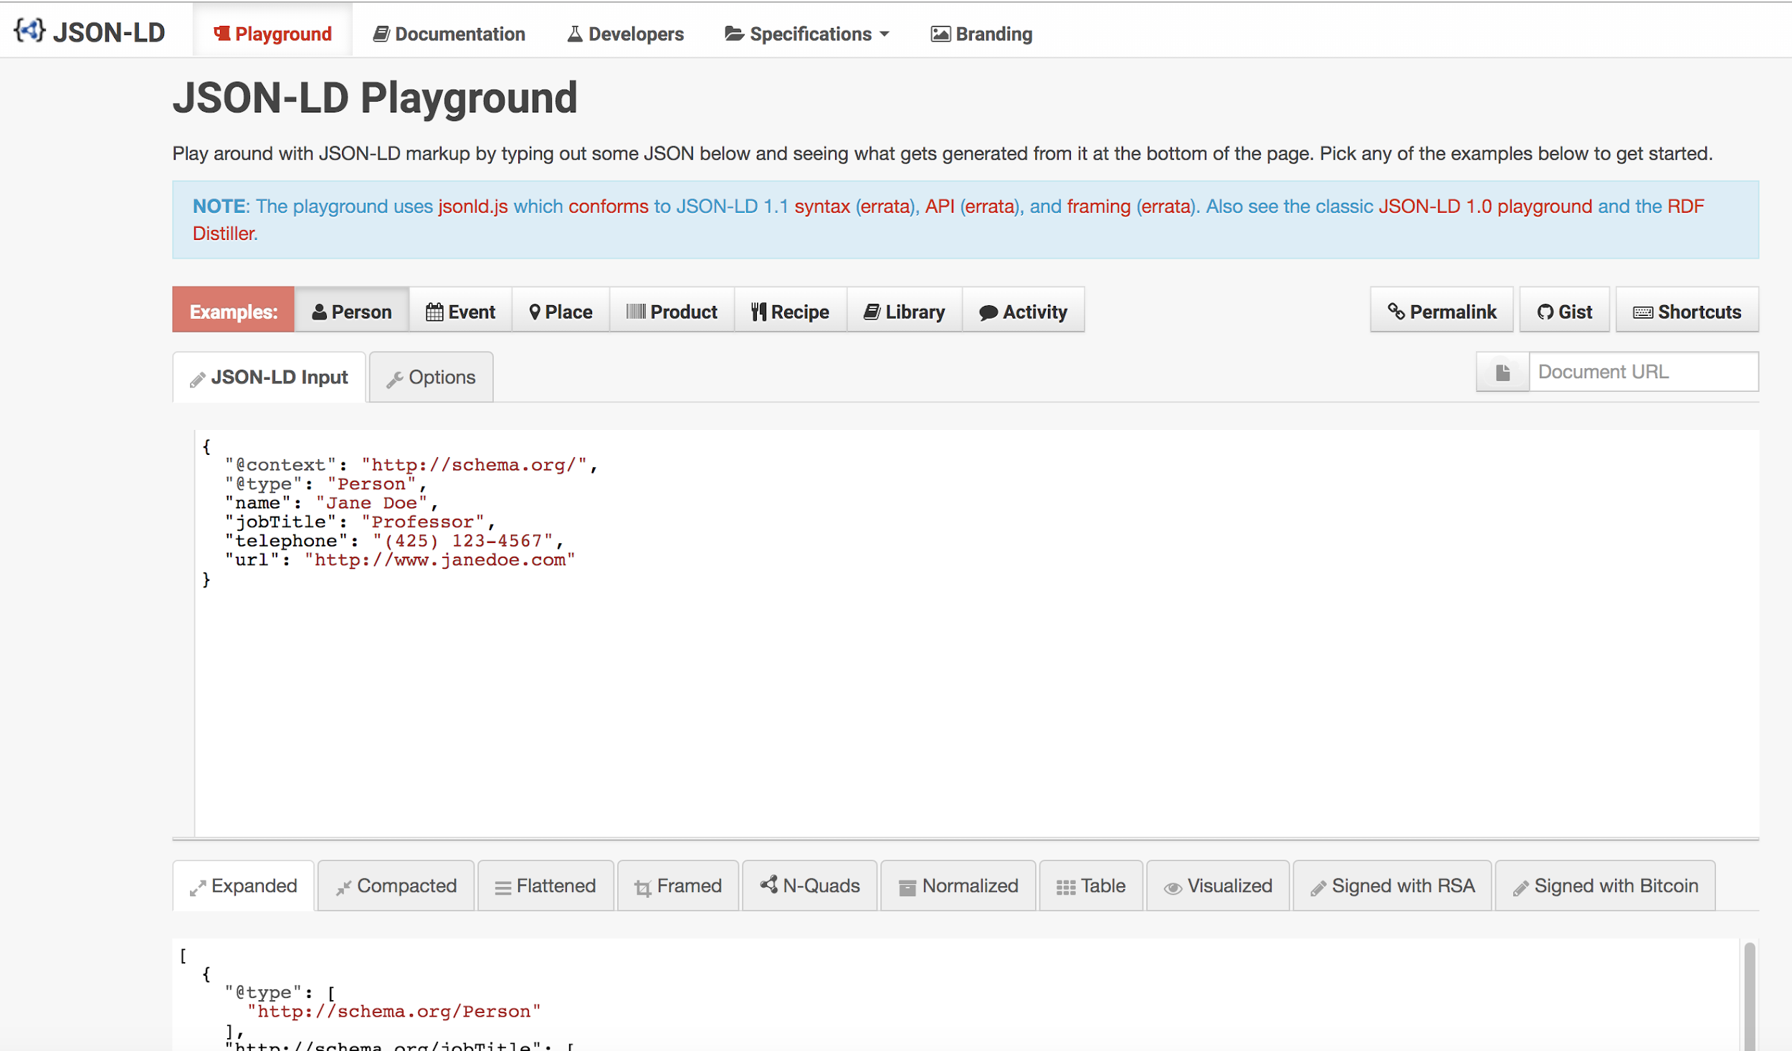

Hydra

http://www.markus-lanthaler.com/hydra/

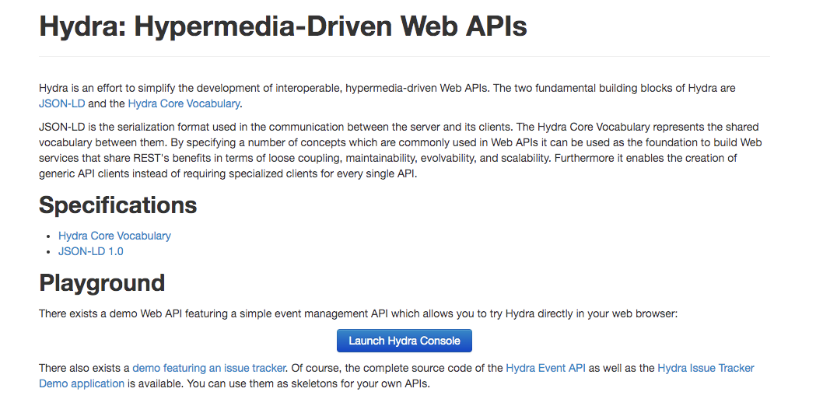

http://www.twilio.com/docs/errors/20003

